Github link: <https://github.com/sowmyakamaraju/Big-Data-Analytics>

Task 2- Cloudera

Sub Task1: Accessing UMKC cloudera servers

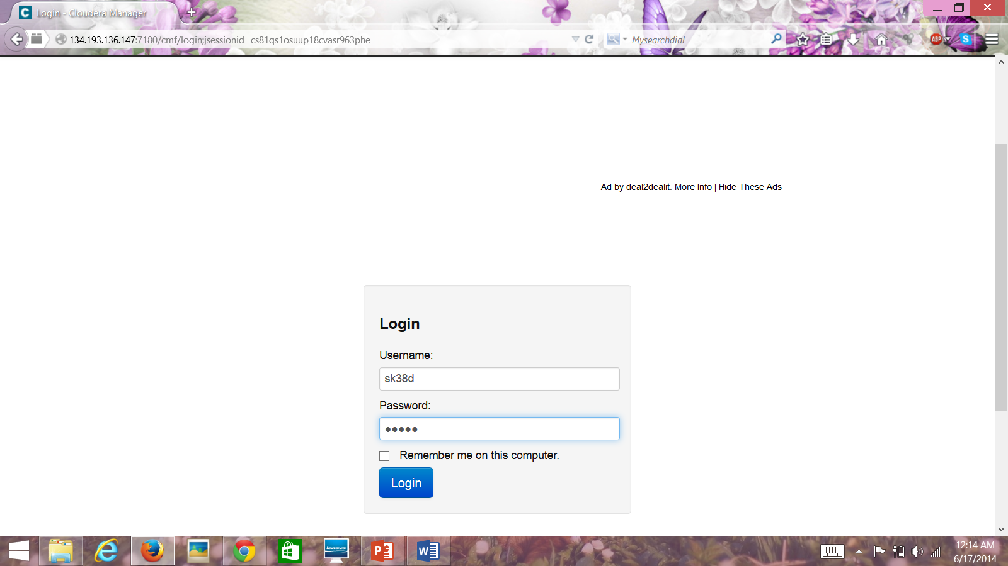  
Accessing UMKC servers through PUTTY

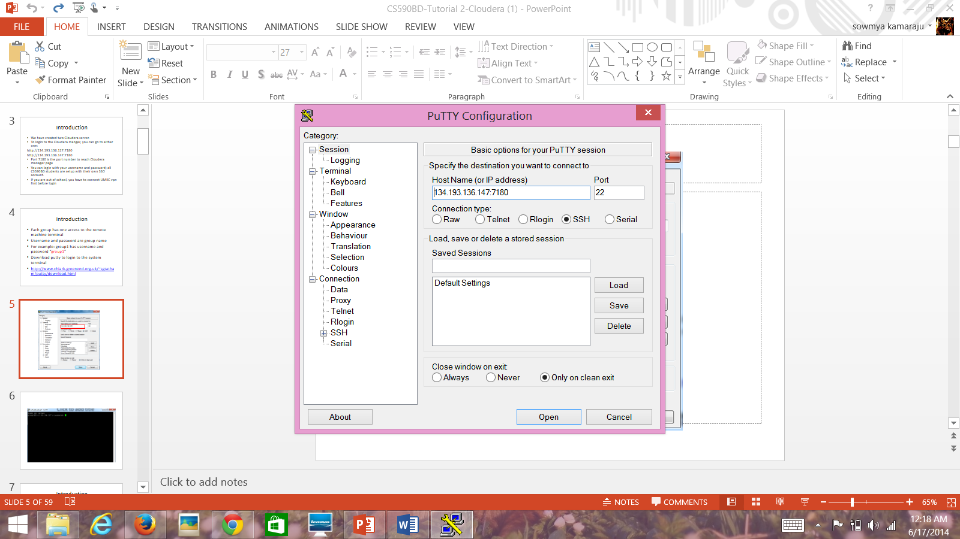

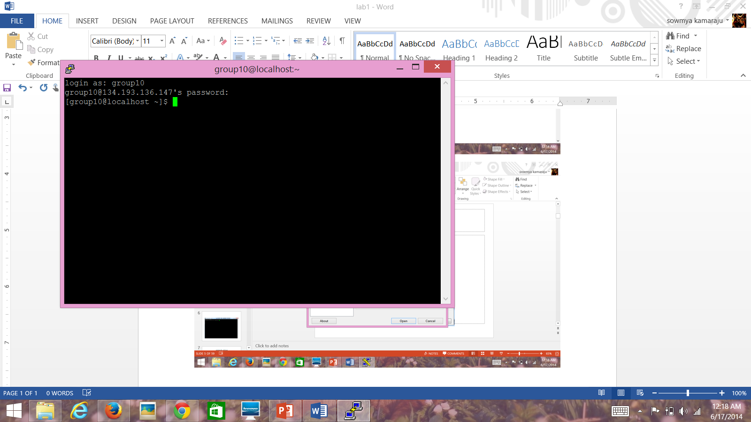

Subtask 2: Installing cloudera in Virtual box

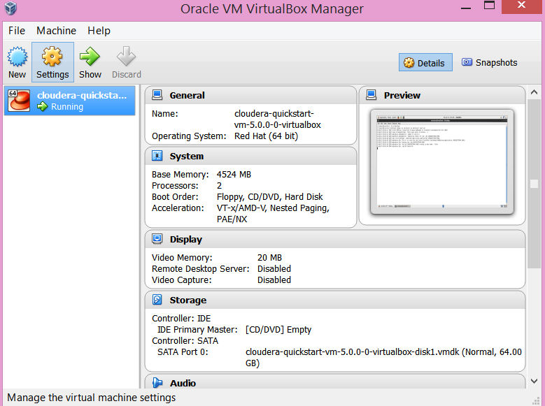

Subtask 3: Transferring files to cloudera

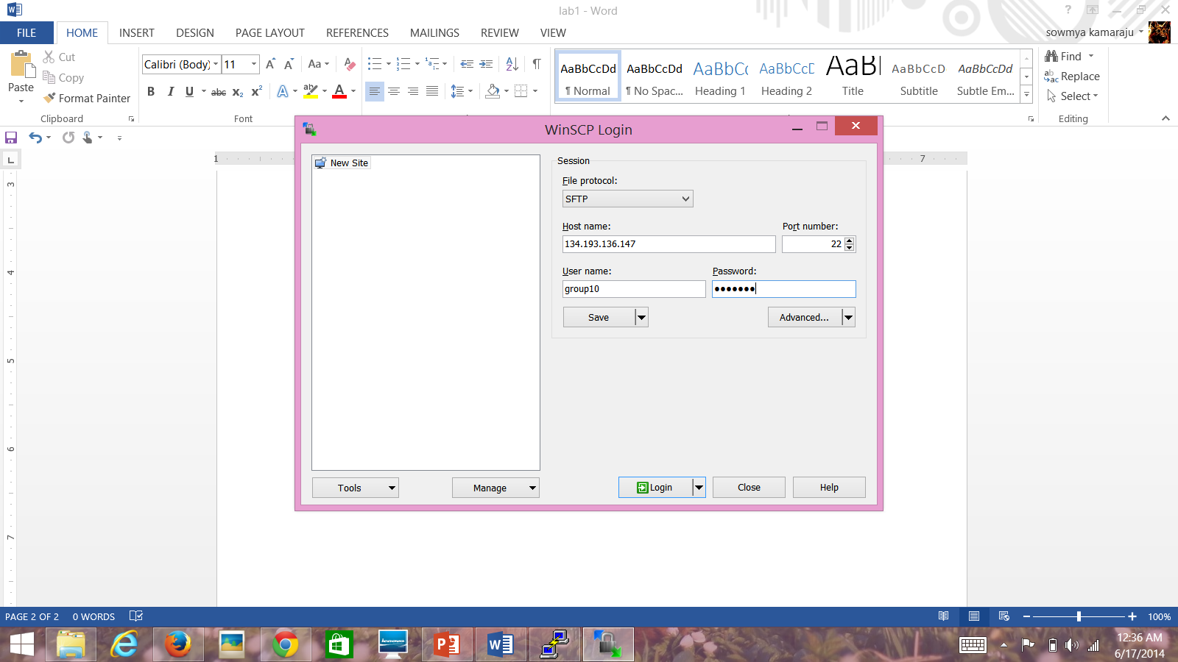

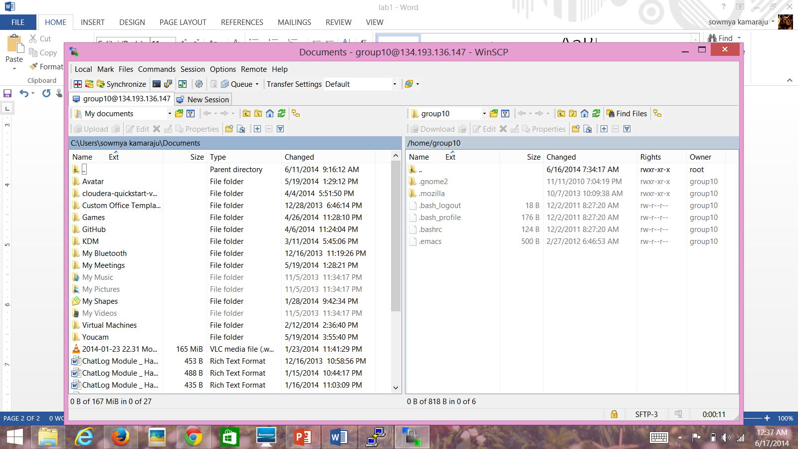

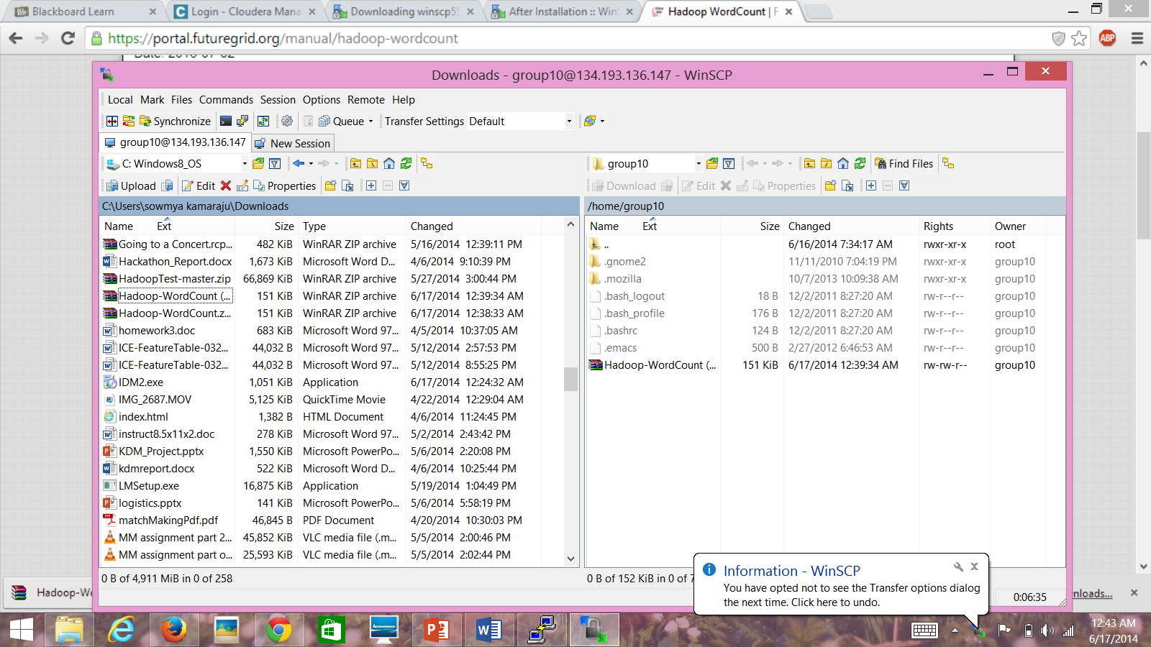

Subtask 4-Running Wordcount program on cloudera

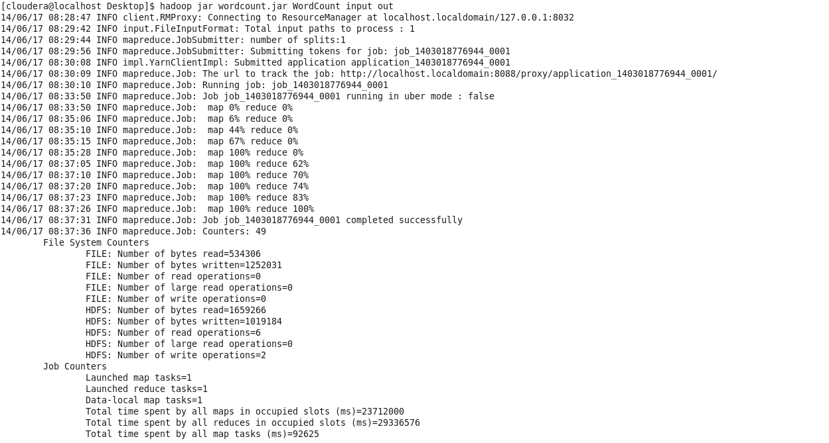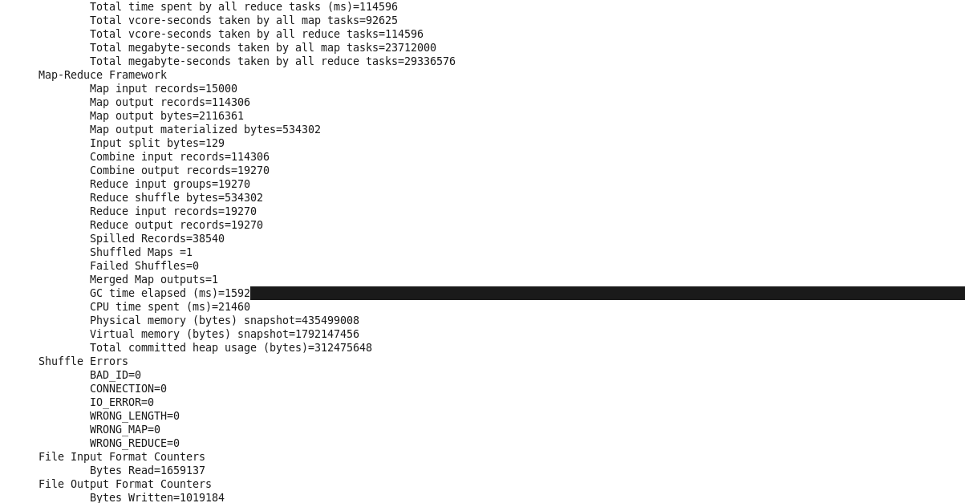

Subtask 5: Building a Hadoop jar

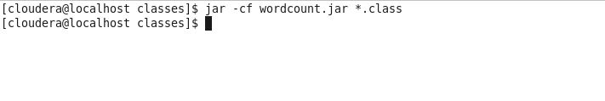

Subtask 6: Java Based restful service in cloudera

Task3-Github and Scrumdo

Subtask 1- Creating Github account

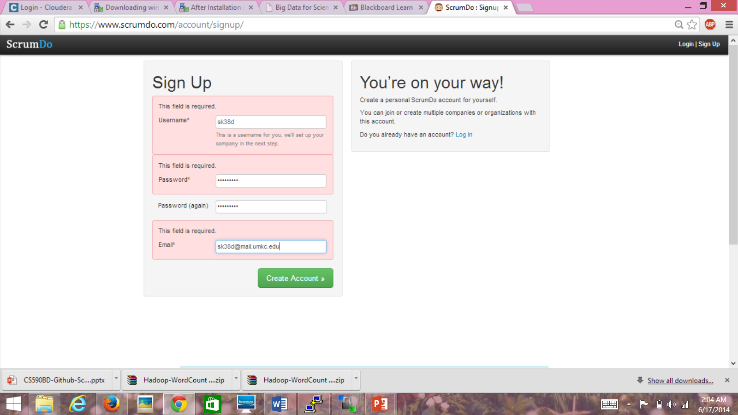

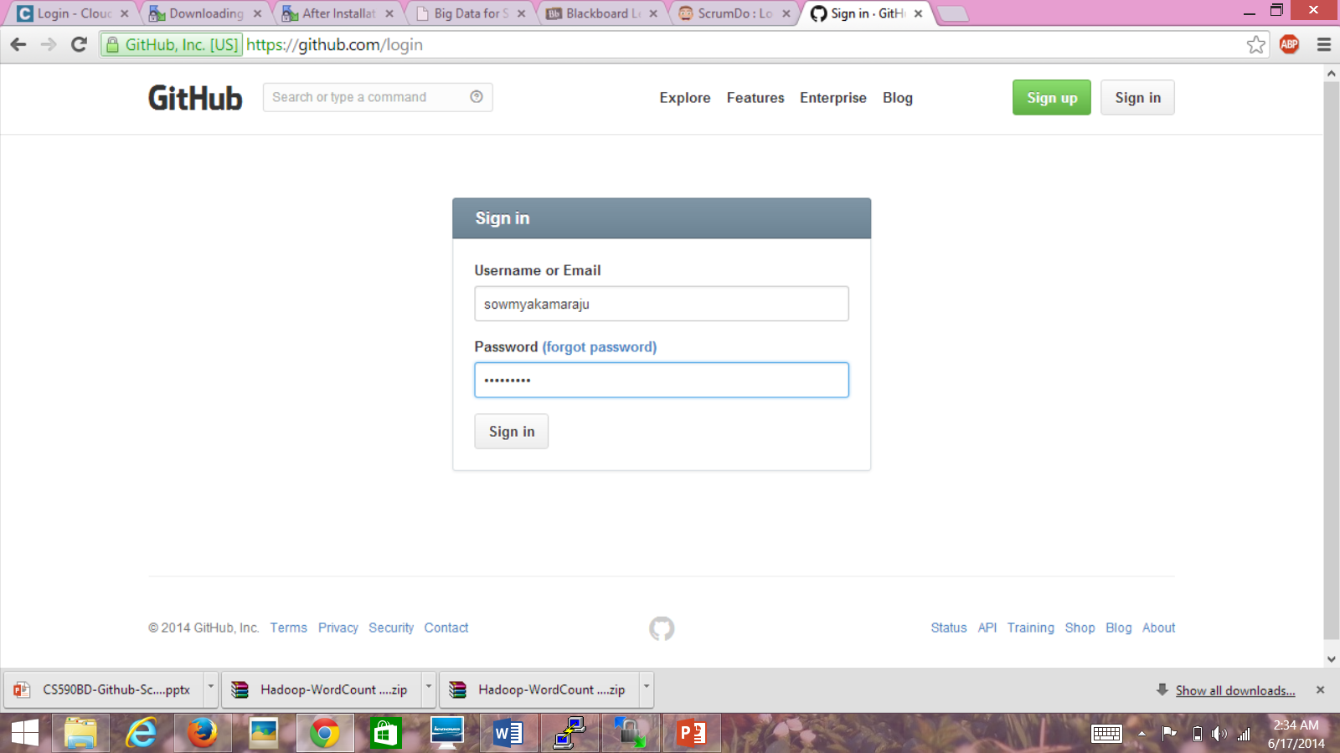

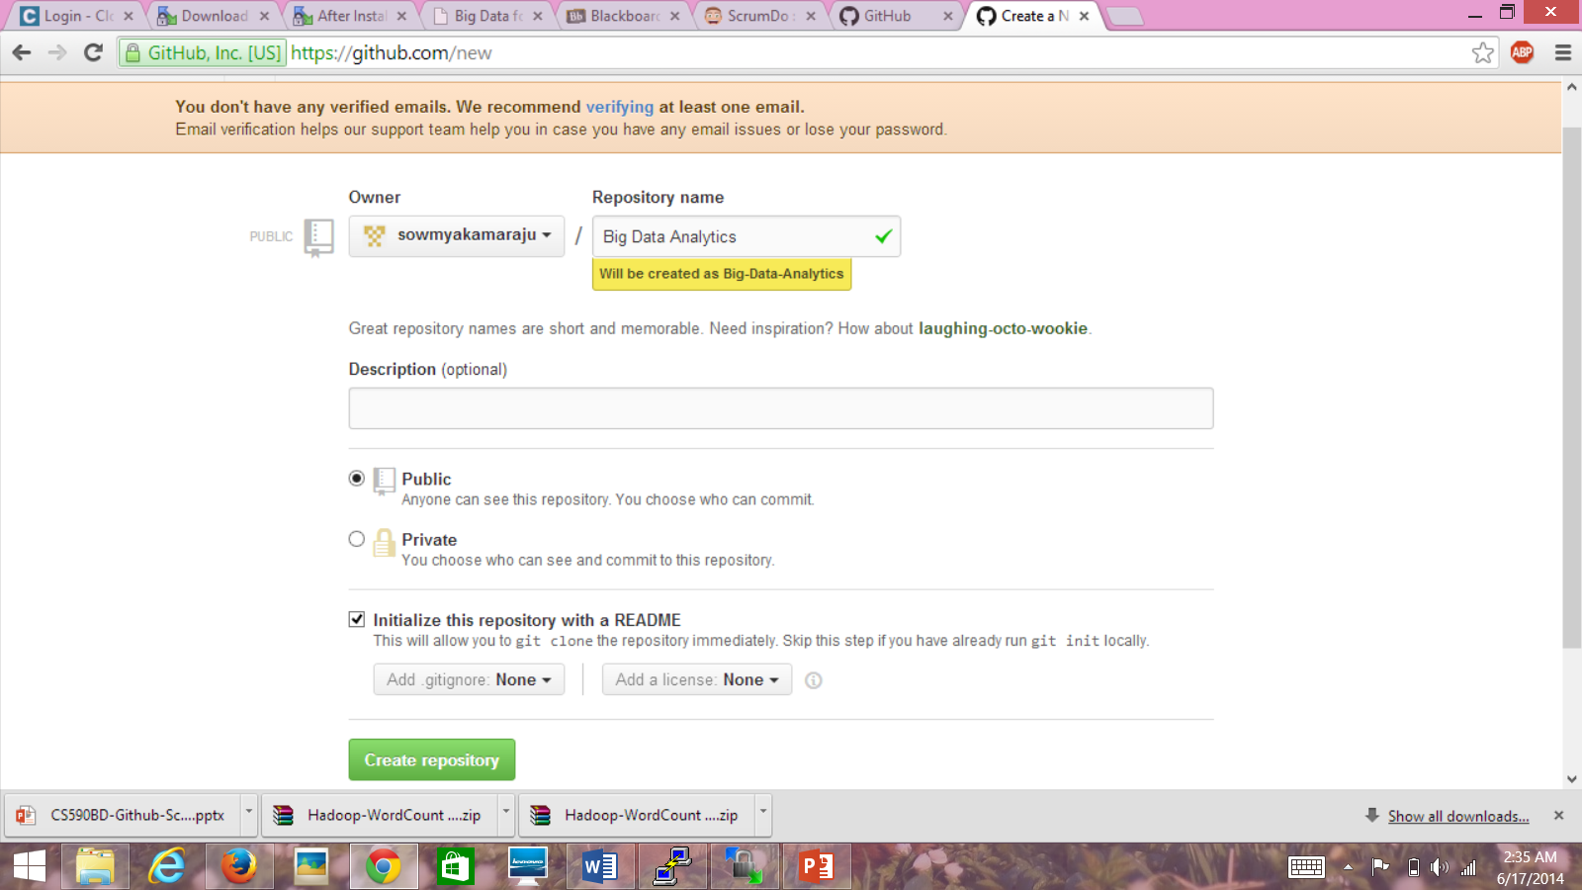

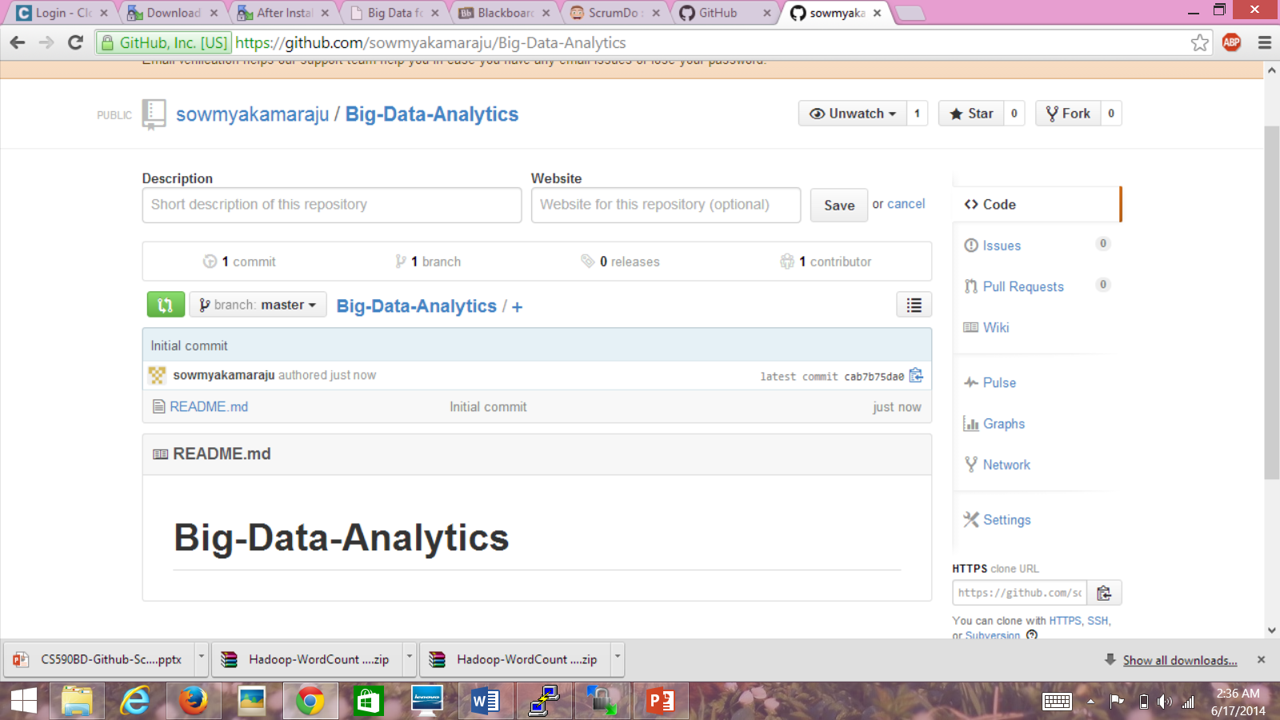

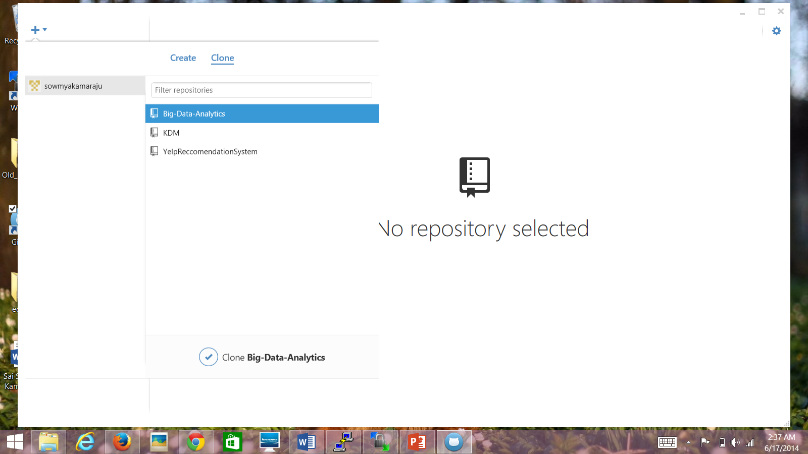

Creating and design Scrumdo projects

